Cointegration and ECM: EURUSD and USDCHF
Method 27 / Engle-Granger on log closes / one-lag ECM / Alpari D1 full available history

Study setup
Logical pair: PX=EURUSD , PY=USDCHF
Broker symbols: EURUSD_i , USDCHF_i
Snapshot: 2026-11-03_majors_alpari_D1
Timeframe: D1
Matched window: 1999-01-05 to 2026-11-02 (UTC bar dates)
Matched level count n: 7186
Dropped unfinished last bar dated 2026-11-03 UTC after a tick-volume check against the prior complete day.
ECM lags of deltas: 1
Complete matched rows (Excel): EURUSD-USDCHF_Coint_D1.xlsx
Complete matched rows (HTML table): EURUSD-USDCHF_Coint_D1_data.html

Method carried forward
Engle-Granger cointegration works on log price levels, not returns. For each unordered pair, PX is the left leg and PY the right leg. Step one: OLS ln(PY) = alpha + beta * ln(PX) + e. Step two: statsmodels Engle-Granger coint test on (ln(PY), ln(PX)). Error-correction: delta ln(PY)_t = c + kappa * e_{t-1} + lagged delta ln(PY) and delta ln(PX) (one lag each) + u_t. Headline is the Engle-Granger p-value (lower = stronger evidence of a stationary spread) with kappa and beta reported alongside. Same-sample Pearson r of log returns is a side check only. beta is not an automatic lot-size hedge. This is not a trading signal.

Results (headline)
alpha: 0.187234
beta: -0.742026
Engle-Granger t: -0.422872
Engle-Granger p: 0.969391
5% critical value: -3.336981
ECM kappa: -0.000308
kappa t-stat: -0.7438
ECM R^2: 0.002350
spread std: 0.187542
Pearson r (returns): -0.749204

Conclusion
Engle-Granger for PY=USDCHF on PX=EURUSD: beta=-0.7420, alpha=0.1872, coint_t=-0.4229, p=0.9694 (5% crit=-3.3370). ECM kappa=-0.0003 (t=-0.74). Pearson r of returns = -0.7492. beta is not a lot-size hedge. Not a trading signal.

Charts
Daily closes

Engle-Granger residual spread
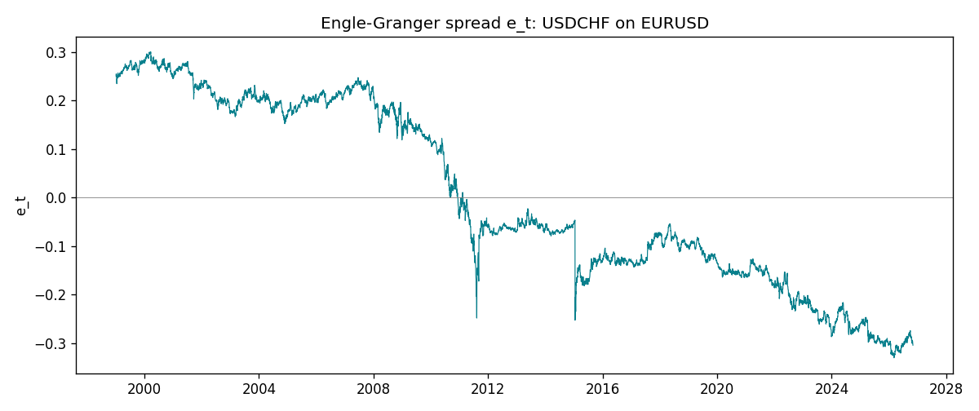
Daily log returns
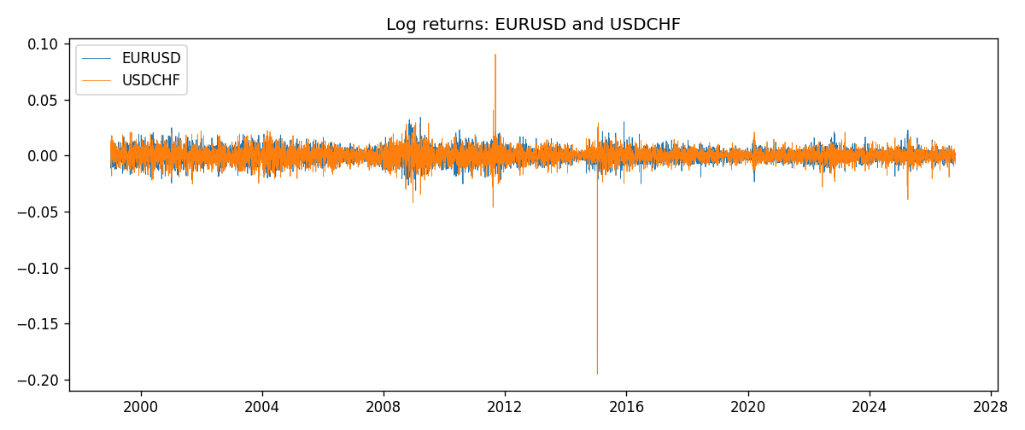

Data report
Matched rows are in the sibling Excel workbook named EURUSD-USDCHF_Coint_D1.xlsx. Embedding all rows as a Word table is impractical; this file holds column summaries and the first and last 15 matched rows.
Column summaries
column | count | mean | std | min | 25% | 50% | 75% | max
EURUSD_open | 7186 | 1.181536 | 0.15083018 | 0.8272 | 1.086205 | 1.16621 | 1.29401 | 1.5995
USDCHF_open | 7186 | 1.0974503 | 0.25221737 | 0.72022 | 0.9205325 | 0.9899 | 1.23765 | 1.8219
EURUSD_high | 7186 | 1.1866696 | 0.15143104 | 0.8326 | 1.090285 | 1.17131 | 1.299445 | 1.6038
USDCHF_high | 7186 | 1.102742 | 0.25396197 | 0.73305 | 0.924775 | 0.99353 | 1.2422 | 1.8313
EURUSD_low | 7186 | 1.1765242 | 0.15015364 | 0.8227 | 1.0820725 | 1.16258 | 1.2885325 | 1.5865
USDCHF_low | 7186 | 1.0923313 | 0.25063382 | 0.08565 | 0.91721 | 0.98623 | 1.2315 | 1.8121
EURUSD_close | 7186 | 1.1815785 | 0.15080545 | 0.8267 | 1.0860875 | 1.166185 | 1.2941 | 1.5997
USDCHF_close | 7186 | 1.0974447 | 0.25212504 | 0.72025 | 0.920795 | 0.98995 | 1.237525 | 1.8217
EURUSD_tick_volume | 7186 | 103207.57 | 173534.06 | 218 | 9426 | 52774.5 | 99579.75 | 1471626
USDCHF_tick_volume | 7186 | 74325.102 | 113489.5 | 18 | 12800 | 40232.5 | 70435.25 | 858589
EURUSD_spread | 7186 | 19.339549 | 16.550572 | 0 | 8 | 12 | 20 | 50
USDCHF_spread | 7186 | 26.036877 | 24.695014 | 0 | 5 | 16 | 50 | 100
EURUSD_real_volume | 7186 | 4.0330482e+10 | 1.6691688e+11 | 0 | 0 | 0 | 0 | 3.6149665e+12
USDCHF_real_volume | 7186 | 2.3290849e+10 | 8.9127816e+10 | 0 | 0 | 0 | 0 | 1.9331921e+12
EURUSD_log_price | 7186 | 0.15860896 | 0.12902139 | -0.19031341 | 0.08258179 | 0.15373774 | 0.25781547 | 0.46981611
USDCHF_log_price | 7186 | 0.06954165 | 0.21056517 | -0.32815691 | -0.08251785 | -0.01010084 | 0.21311341 | 0.59977013
EURUSD_log_return | 7186 | -3.06e-06 | 0.00580427 | -0.03123819 | -0.00324267 | 0 | 0.00325778 | 0.03433183
USDCHF_log_return | 7186 | -6.921e-05 | 0.00659379 | -0.19545699 | -0.00335085 | 8.077e-05 | 0.003323 | 0.09051364
spread_e | 7186 | 0 | 0.18754216 | -0.33015676 | -0.14734329 | -0.06121903 | 0.19783187 | 0.30029636
ecm_fitted | 7185 | -6.977e-05 | 0.00031964 | -0.00597428 | -0.00021156 | -7.25e-05 | 6.909e-05 | 0.01407238
First 15 matched rows (selected columns)
time | EURUSD_log_price | USDCHF_log_price | spread_e | EURUSD_log_return | USDCHF_log_return
1999-01-05 | 0.16194877 | 0.31656103 | 0.24949761 | -0.0048360507 | 0.0039424743
1999-01-06 | 0.1504008 | 0.33016668 | 0.25453436 | -0.011547966 | 0.013605652
1999-01-07 | 0.15802886 | 0.3207783 | 0.2508062 | 0.0076280636 | -0.0093883841
1999-01-08 | 0.14712606 | 0.33181857 | 0.2537563 | -0.010902799 | 0.011040268
1999-01-11 | 0.14002278 | 0.33711489 | 0.2537818 | -0.007103287 | 0.0052963193
1999-01-12 | 0.14453315 | 0.32728733 | 0.24730105 | 0.0045103728 | -0.0098275602
1999-01-13 | 0.1553785 | 0.30902763 | 0.23708889 | 0.010845346 | -0.018259701
1999-01-14 | 0.1553785 | 0.30660196 | 0.23466322 | 0 | -0.0024256692
1999-01-15 | 0.14522525 | 0.32454424 | 0.24507152 | -0.010153245 | 0.01794228
1999-01-18 | 0.14885095 | 0.3213586 | 0.24457624 | 0.0036256946 | -0.0031856384
1999-01-19 | 0.14867859 | 0.32128608 | 0.24437583 | -0.00017235436 | -7.2518946e-05
1999-01-20 | 0.14548467 | 0.32851207 | 0.24923184 | -0.0031939256 | 0.0072259871
1999-01-21 | 0.14850621 | 0.3246888 | 0.24765064 | 0.0030215416 | -0.0038232689
1999-01-22 | 0.14729869 | 0.32454424 | 0.24661006 | -0.0012075213 | -0.0001445609
1999-01-25 | 0.14427349 | 0.32699893 | 0.24681998 | -0.0030251979 | 0.0024546976
Last 15 matched rows (selected columns)
time | EURUSD_log_price | USDCHF_log_price | spread_e | EURUSD_log_return | USDCHF_log_return
2026-10-13 | 0.11301614 | -0.18339413 | -0.28676687 | 0.0037402957 | -0.0024955621
2026-10-14 | 0.10925791 | -0.1804553 | -0.28661674 | -0.0037582255 | 0.0029388325
2026-10-15 | 0.11486322 | -0.19024083 | -0.29224298 | 0.0056053107 | -0.0097855323
2026-10-16 | 0.11663571 | -0.19386391 | -0.29455083 | 0.0017724895 | -0.0036230826
2026-10-19 | 0.11409625 | -0.19022874 | -0.2928 | -0.0025394633 | 0.0036351779
2026-10-20 | 0.11648442 | -0.19285686 | -0.29365604 | 0.0023881672 | -0.0026281224
2026-10-21 | 0.11616395 | -0.19325713 | -0.29429411 | -0.00032046717 | -0.00040027413
2026-10-22 | 0.11456899 | -0.19806077 | -0.30028125 | -0.0015949606 | -0.0048036381
2026-10-23 | 0.11323047 | -0.19240826 | -0.29562195 | -0.001338521 | 0.005652514
2026-10-26 | 0.11095981 | -0.19056746 | -0.29546604 | -0.0022706559 | 0.0018407959
2026-10-27 | 0.10680747 | -0.18795741 | -0.29593714 | -0.004152342 | 0.0026100526
2026-10-28 | 0.10903376 | -0.18897162 | -0.29529938 | 0.0022262927 | -0.0010142111
2026-10-29 | 0.1112909 | -0.19383964 | -0.29849254 | 0.0022571351 | -0.0048680164
2026-10-30 | 0.11014505 | -0.19312369 | -0.29862685 | -0.0011458446 | 0.00071594559
2026-11-02 | 0.11226562 | -0.20026966 | -0.3041993 | 0.002120569 | -0.0071459744

